Day 1 -16th May 2025

Mohammad Moinuddin (@mdmoindn/201934371)

**Task: 1**

**What is SDLC?**

**SDLC**: SDLC (Software Development Life Cycle) is a step-by-step process to build a software then analyze requirements. Next, they design the system, develop the code, and test for the bugs. Finally, the software is deployed and maintained for updates. It ensures quality, saves time, and avoids costly mistakes.

**Task: 1**

**Why is SDLC?**

**Purpose of SDLC**: To provide a structured approach for building reliable and high quality software on time and in cost budget while minimizing the errors.

**Need of SDLC**:

To ensure the clients meets requirement while reducing the risks, bugs, and development costs and improve teamwork and project management. We need SDLC for support and maintenance and future updates.

**Task 3:**

**What are the stages of SDLC?**

Stages in SDLC:

1. **Requirement & Planning:** Understand what the software should do (client needs, features, Requirements of the software).
2. **Designing** – Plan the architecture, UI, Data base.
3. **Development** (Coding) – Build the software by programming.
4. **Testing** – Find and fix the bugs to ensure quality and efficiency of the product.
5. **Deployment** – Release the software for users.
6. **Maintenance** – Updates, bug fixings and improvement of the software developed.

**Task 4:**

**SDLC Models:**

SDLC has different approaches called “models” to manage projects, each with unique strengths.

1. **Waterfall Model**: Waterfall model works like an assembly line where we complete one phase (like planning) before moving to the next (like design). It is a straightforward model but a rigid- if you realize you missed something early on, it’s expensive to go back. Best for projects with crystal clear requirements.

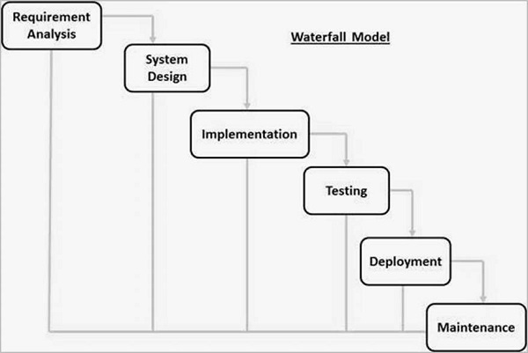

**Applications of Waterfall Model: -**

* We use waterfall models where the project is fixed, well-defined requirements (no changes expected)

* Safety – critical systems where documentation is mandatory.

* Examples: - Banking software ex ATM Transaction systems, tax filling systems.

**Advantages:**

1. Simple and easy to manage
2. Clear documentation.
3. Good for fixed scope projects (e.g., Banking system)

**Disadvantages:**

1. Hard to change requirements later
2. Risk if requirement is unclear
3. **Agile Model**:

Instead of one big launch, work happens in short “sprints” (2-4 weeks), delivering small usable pieces. After each sprint adapting based on feedback is done. Think of it like sculpting you shape the product gradually. Perfect for apps where need changes.

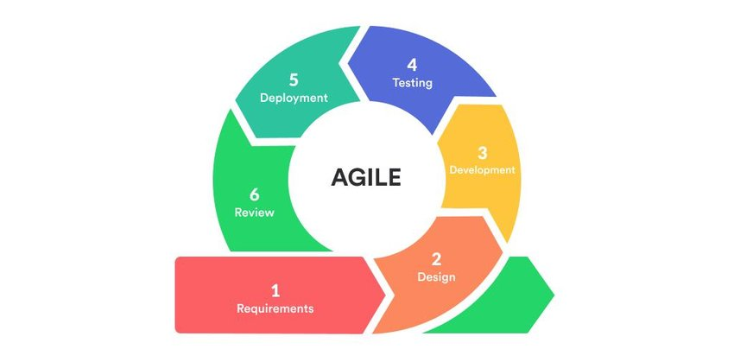

**When to use: -**

Projects where requirements evolve e.g., User feedback shapes the product.

Startups or competitive markets needing fast release.

Perfect for apps where need changes.

**Applications of Agile Model**:

1 Mobile apps like Instagram adding reels based on trends

2 E- commerce platforms (e.g., Shopify rolling out new payment options)

**Advantages:**

1. Highly flexible (adapts to changes)
2. Fast delivery of small features

**Disadvantages:**

1. Requires heavy team collaboration.
2. Requires experienced teams.
3. **Iterative model**: Builds a basic version first, then improve it in cycles. Unlike Agile, it doesn’t requires delivering working software every sprint- just refining the product over time.

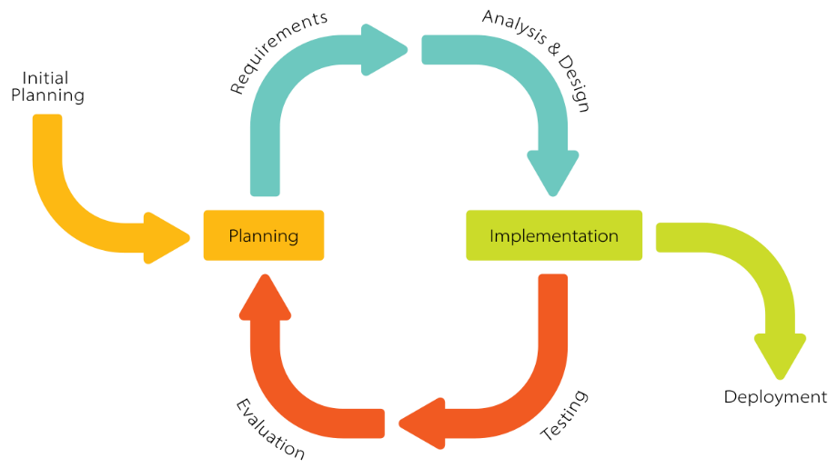

**When to use:**

Large projects where core features are clear but details need refinement.

**Applications of Iterative Model**:

1.Video Games (Ex releasing a beta version, then adding levels)

**Advantages:**

1. Easy to manage risks
2. More flexible than waterfall model.

**Disadvantages:**

1. Can be costly (repeated cycles)
2. Needs strong project management
3. Not ideal for small projects.
4. **DevOps Model**: Focuses on speed and automation. Developers and IT operations teams work together to release updates frequently (Sometimes daily!). Uses tools for automated testing.

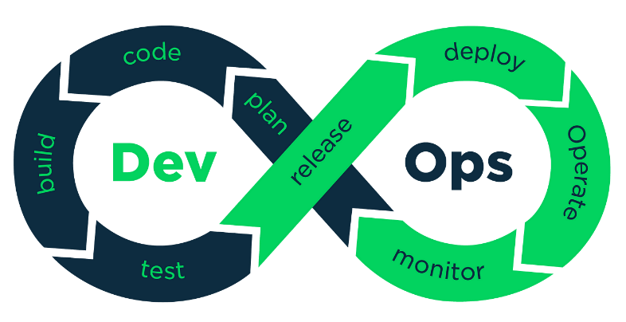

**When to use**:

Cloud based services, Requires continuous updates.

Teams aiming for automated testing/deployment.

**Applications of DevOps Model:**

**Streaming platforms:** (Example Netflix updating its recommendation algorithm daily)

**Cybersecurity:** (Antivirus software pushing real-time patches)

**Advantages**:

1.Extremely fast releases.

2.Automated testing.

**Disadvantages**:

1. Complex setups
2. Daily changes/ monitoring.
3. Expensive.

**TASK 7:**

**What is scrum?**

Scrum is an agile framework used for developing, delivering, and managing complex projects, especially in software development. It promotes teamwork, accountability and a well progress towards a well-defined goal.

**TASK 8:**

**What is sprint?**

A Sprint is a short, fixed period of time (usually 1 to 4 weeks) where a team works and finish a specific piece of work. It is one of the main parts of scrum.

**TASK 9**

**Dos and Don’ts of Sprint?**

**Dos of spirit**

1. **Focus on spirit Goal –** work only on the tasks planned for the spirit
2. **Communicate Daily –** Attend daily standups to share progress and any blockers
3. **Break tasks into small steps –** Make sure tasks are clear and manageable

**Don’ts of Spirit:**

1. **Don’t add new work in the middle of spirit –** Only work on what was planned unless the team agrees to change
2. **Don’t Skip daily standups:** It helps everyone stay aligned
3. **Don’t delay reporting problems:** Raise issue as soon as you face them.

**Backlog:**

A backlog is a to-do list for the development team. It contains everything that needs to be built, fixed or improved in the products.

**Stories:**

A story is an individual item in the backlog. It represents a small piece of work that delivers value to the user.

In other words, we can say stories are small tasks or features within the backlog that describe what the user wants.

**SCRUM Artifacts**:

Scrum artifacts are key documents or tools used in scrum to help the team stay organized, track work, and deliver value, they show what work is planned, what’s being done, and what’s completed.

**The 4 main SCURM Artifacts**:

**Product Backlog:**

* A list of everything that need to be built in the product
* Contains User stories, features, bugs, and improvements.
* Managed by the product owner.
* Continuously updated and prioritized.

**Sprint Backlog:**

A list of items from the product backlog chosen for the current sprint

* Owned by the development team
* Shows what the team is working on right now.

**Increment:**

*The working product or feature that is completed at the end of a sprint.

*It should be usable and potentially shippable.

**Burn down chart:**

* A Burndown chart is a graph used in a Scrum to track the progress of work during a sprint or a project
* It shows how much work is left to do vs time remaining.

**What are Ports and Protocols:**

**Ports and protocols are elements of computer networking that helps computer communicate with each other’s effectively.**

**Ports:** Think of ports like different doors or channels in a computer through which the data can flow. Just like how a house has different doors for different purpose. A computer has different ports for different types of communication.

* Ports are identified by numbers (0-65535)
* Port 80: Used for regular web browsing (HTTP)
* Port 443: Used for secure web browsing (HTTPS)

**Protocols**: They are like the rules and language that computer uses to communicate with each other. Just like how people need a common language to understand each other, computer need protocols to understand and exchange data.

**TYPES of NETWORKS:**

**1 LAN (Local Area network)**

* A network that connects devices in a small area like an office, home, or school.
* Usually covers a single building or campus.

**2 WAN (Wide Area network)**

* Connects network over larger geographical distances.
* The internet is the largest WAN.
* A company connecting office in different cities can be a example.

**3.MAN (Metropolitan Area Network)**

* Larger than a LAN but smaller than a WAN
* Typically covers a city or large campus
* Example: A company network

**4.VPN (Virtual Private Network)**

* Creates a secure, encrypted connection over a public network
* Allows safe remote access to another networks
* Accessing your network safely securely from home

**5.WLAN (Wireless Local Area network)**

* Similar to LAN but uses wireless connection (Wi-fi)
* No need for physical cables

**6.PAN (Personal Area network)**

* Very small with a range of 10 meters
* Example connecting your phones to wireless earbuds via Bluetooth.

**WHAT DO YOU KNOW ABOUT DNS? DOMAIN NAME SYSTEM**

DNS is a fundamental system that acts like the internet’s phone book.

It translates human-readable domain names like [www.amazon.com](http://www.amazon.com) into IP addresses like IP address that computer uses to identify each other.

**Main components**:

* DNS servers
* Domain names
* DNS Zones

How it works: When you type a website address your computer first checks its local DNS cache

* If not found, it queries a DNS resolver.
* The resolver then works with DNS hierarchy: Root server, Top level servers .com .org etc

**What are the different types of topologies?**

A topology is the way computer networks are arranged and how different network devices are connected to each other. We can think of it as the layout or structure of how devices communicate in a network.

**Bus topology**

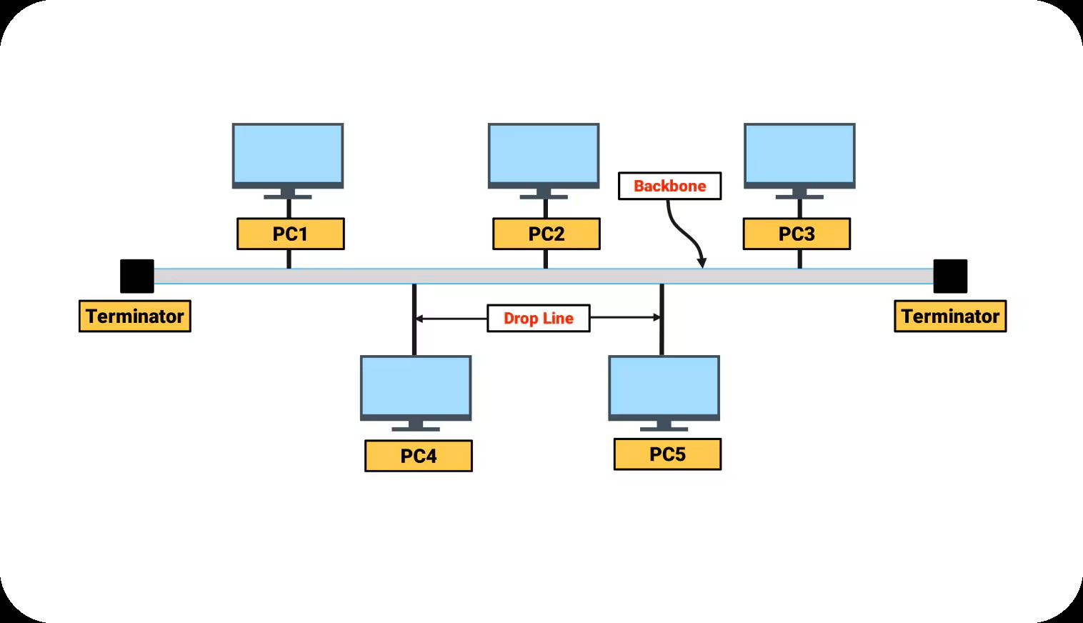

* **All devices are connected to a single central cable (called a bus)**
* **Data travels in both directions on the cable**

**Star topology**

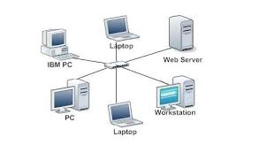

* **All devices connected to a central device (hub or a switch).**
* **Data passes through the central point**

**Ring topology**

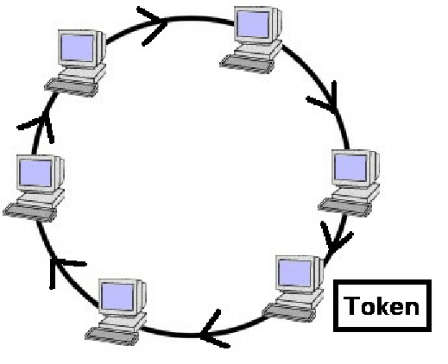

* **Devices are connected in a circular loop**
* **Data travels in one direction ( or both, in a dual ring )**

**Mesh topology**

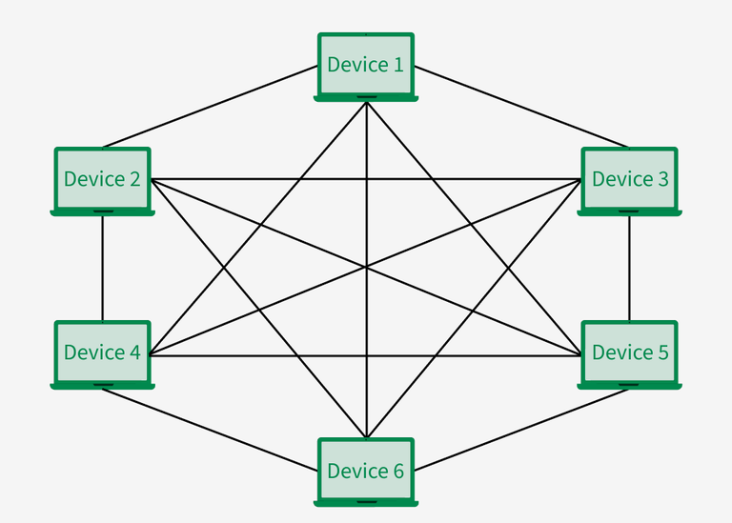

* **Each device is connected to every other device directly**
* **Common in wireless or critical systems**

**What IS the OSI Model?**

OSI stands for Open System Interconnection. It is a standard model used to understand how data moves from one computer to another over a network.

The OSI model has 7 layers, and each layer has a specific role in the communication process. Think of it like a step-by-step path that data follows to travel across a network.

**The 7 layers of the OSI Model (FROM TOP TO BOTTOM):**

**1 Application layer:** This is where you interact with the network – The apps we use every day.

* What it does: it interacts directly with a software application like web browser, email etc.
* Function – File transfers, emails, browsing, network services

**2 Presentation Layer:** Converts the data into a format that the receiving device can understand.

* What it does: Translates, encrypts, compresses data.
* Function: Data formatting, encryption/decryption, compression

1. **Session layer:** Manages the connection between two devices – starts and ends the conversation.

* What it does: starts, maintain, and ends communication session between devices
* Function – Session control, login/proof.
* Example : I start and end a phone call – this is what this layer does with computer communication.

1. **Transport Layer:** Breaks data into small parts (packets) and ensures it arrive correctly and un order.

* What it does – Delivers data accurately and in the right order
* Function- Error recovery, data flow control

1. **Network Layer:**

* What it does – Finds the best path to send data across networks
* Function – Routing, logical addressing (IP)

1. **DATA LINK LAYER:**

* What it does – Moves data between devices on the same network (Local network)
* Functions: MAC (MEDIA ACCESS CONTROL) addressing, error detection (Within the same LAN)

1. **PHYSICAL LAYER:**

* What it does – Transfer raw bits (0s and 1s) over the physical medium (like cables or wireless signals)
* Function: Electrical Signals, connectors, cables
* Examples: Ethernet cables, fiber optics, hubs.